Ibraheem

42896

BSCS 5

**Assignment 3**

**DAA**

**Problem 1**

**Kruskal algorithm**

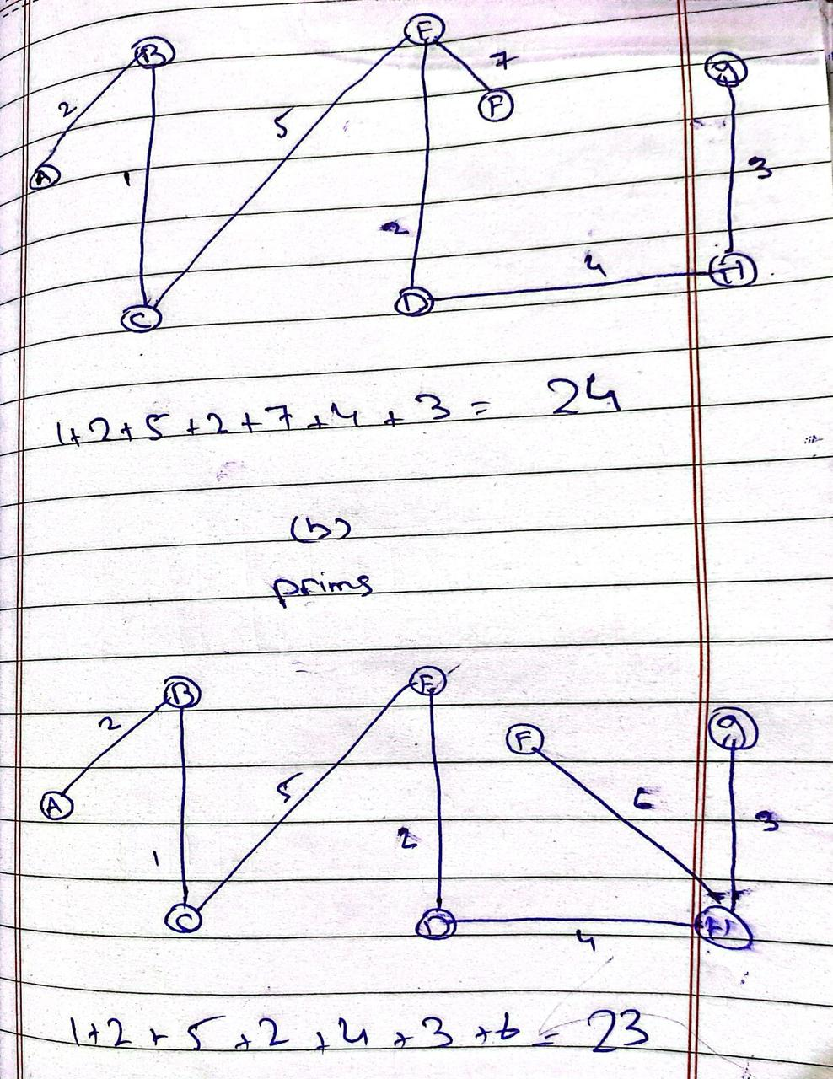

**Problem 2**

1. **:**

**Steps of Dijkstra’s Algorithm, Source = A**

**Graph Edges:**

* A → B (5), A → C (11)
* B → C (2), B → E (3)
* C → E (4), C → D (6)
* E → D (1), E → F (7)
* D → F (8)

**Part b :**

#### Can Dijkstra’s algorithm handle ****negative weights****?

* **No.** Dijkstra’s algorithm assumes that once a node’s shortest distance is finalized, it won't change. Negative weights **violate** this.
* Example: If a shorter path with a negative weight is found **after** visiting a node, Dijkstra will **miss** it.

#### Which algorithm to use instead?

* Use **Bellman-Ford Algorithm**. It works correctly with negative weights (as long as there are **no negative cycles**).

**Problem 3 :**

Given two strings A and B, find the **longest contiguous substring** that appears in both.

Example:

* A = "abcdefgyu"
* B = "bcdtyu"

Output: "bcd" (length = 3)

**Dynamic Programming Approach :**

If A[i-1] == B[j-1], then:

dp[i][j] = dp[i-1][j-1] + 1

Else:

dp[i][j] = 0

**problem 4 :**

Given two sequences S and T, the **Longest Common Subsequence** (LCS) problem is to find the length of the longest subsequence present in **both** sequences.

* **Subsequence**: A sequence derived from another by deleting some or no elements, without changing the order of the remaining elements.
* For example, LCS of "abcdefg" and "bdf" is "bdf" (length = 3).

**Dynamic Programming Solution :**

If S[i-1] == T[j-1]:

dp[i][j] = dp[i-1][j-1] + 1

Else:

dp[i][j] = max(dp[i-1][j], dp[i][j-1])